Games Research – Rafik Miah.

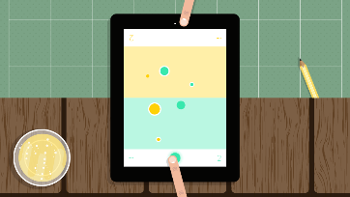

For my games research I looked at OLO, it is priced at £1.49 on the app store, it is not a single player game, for social and online reasons. The graphics and UI are basic compared to other games ie trial fusion, because there is no background environment, only adversarial area, this is a very competitive based game. Fun and exciting.

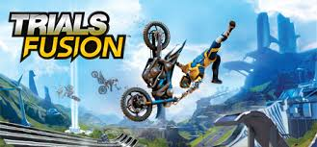

Trails Fusion is a excellent game, Graphically outstanding and physics/gravity stand out as main game play, it seems like a daunting task to create a game of this calibar, although I would enjoy the challenge. Trails Fusion is editors choice and free on the app store ☺



Again this game appears, similar to the above, except that it’s a car, collision and gravity based game. Very enjoyable. High graphics and very polished.

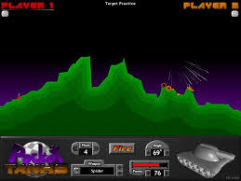

Pocket tanks, seems like a classic remake on ‘worms’ to me, it is very fun and challenging in game play, yet it takes a bit of configuration to get going, this would not be my first idea of game play or style to meet our brief.